**How to load example heart rate project with STM32.**

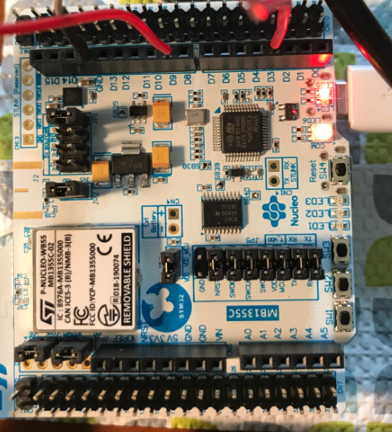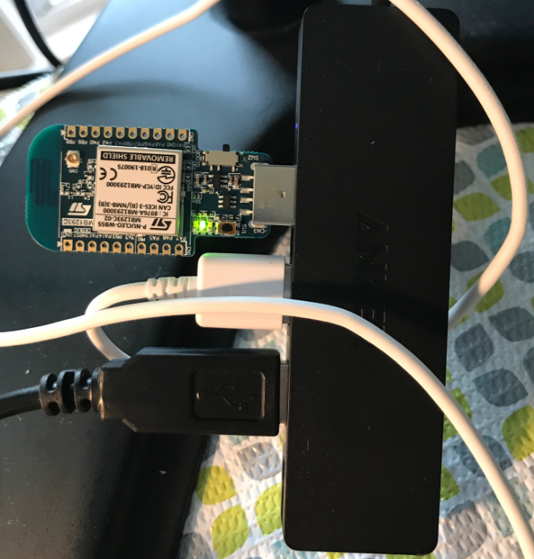

**Hardware configuration**

1. Use a microUSB cable to connect the STM32 board and the computer through USB port. The microUSB port on the STM32 board should use the one label ST-LINK, as shown in the figure above. Plug the Dongle into the USB port of the computer as well.
2. Go to STM programmer, press “connect” to connect the device, make sure you select “ST-LINK”.

Once the board is connected, you should see the round LED (LED6) is flashing, indicating the board is connected with the software from your computer. The red LED (LED5) should be always light up, indicating the power of the device is normal.

**Download the program into the boards.**

1. First download the program to STM32 board, using STM32CubeProgrammer. Navigate to find where the program is saved on your local computer. My STM32 projects were saved under the C:\work, it might be different on your computer.

C:\Work\STM32Cube_FW_WB_V1.6.0\Projects\P-NUCLEO-WB55.Nucleo\Applications\BLE\BLE_HeartRate\SW4STM32\BLE_HeartRate\Debug

1. Then download the program to dongle board, using STM32CubeProgrammer. Navigate to find where the program is saved on your local computer. My STM32 projects were saved under the C:\work, it might be different on your computer.

C:\Work\STM32Cube_FW_WB_V1.6.0\Projects\P-NUCLEO-WB55.USBDongle\Applications\BLE\BLE_HeartRate\SW4STM32\BLE_HeartRate\Debug

1. Once the program is uploaded, you might need to reset the STM32 device by pressing SW4.

Open the “ST BLE Profiles” smart phone app. Press “Scan” and your app should find “HRSTM”. Then select “HRSTM”, and next press “Connect”

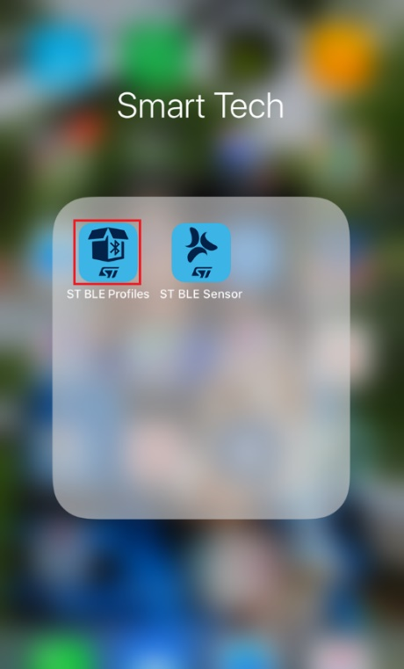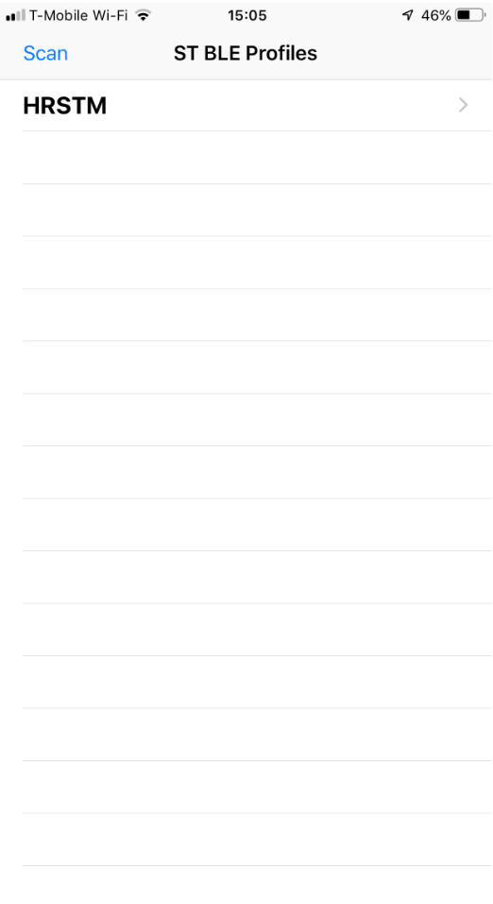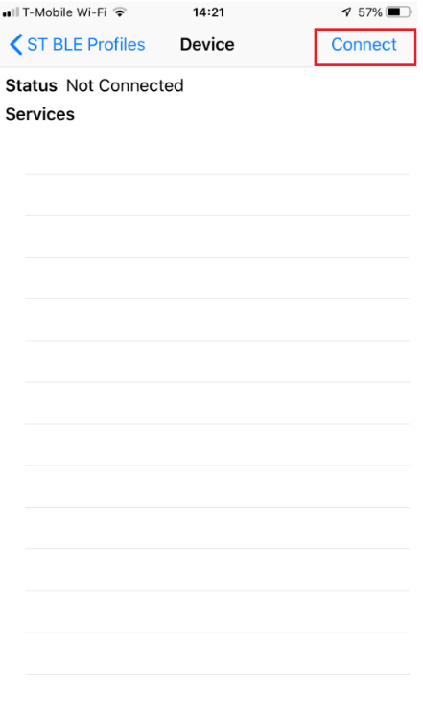

Once your app and the device are connected. You should see “Heart Rate”, click on “Heart Rate”, and then select “Heart Rate Measurement” . You should see the heart rate monitor is running now.

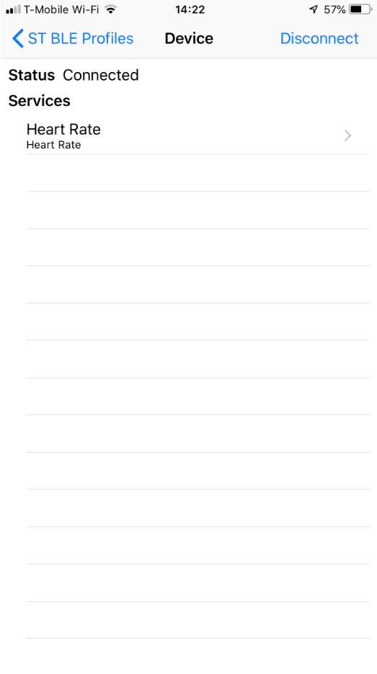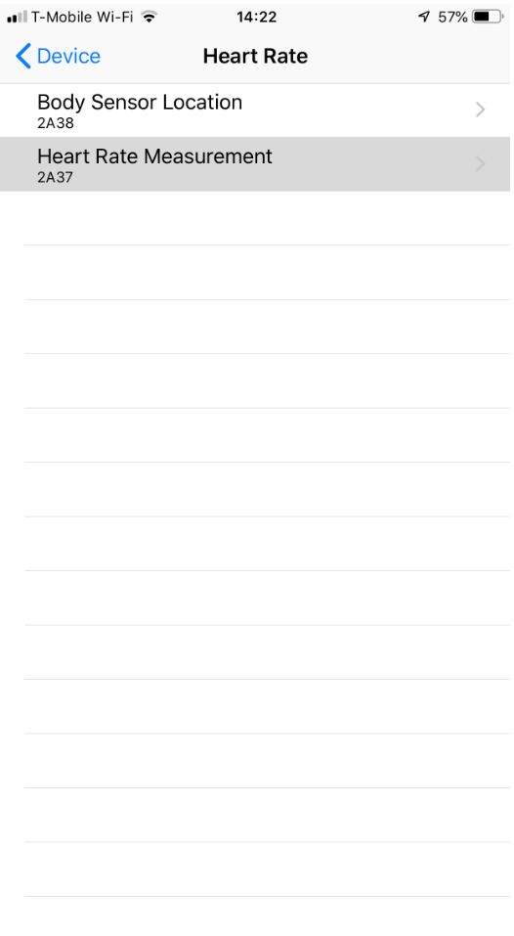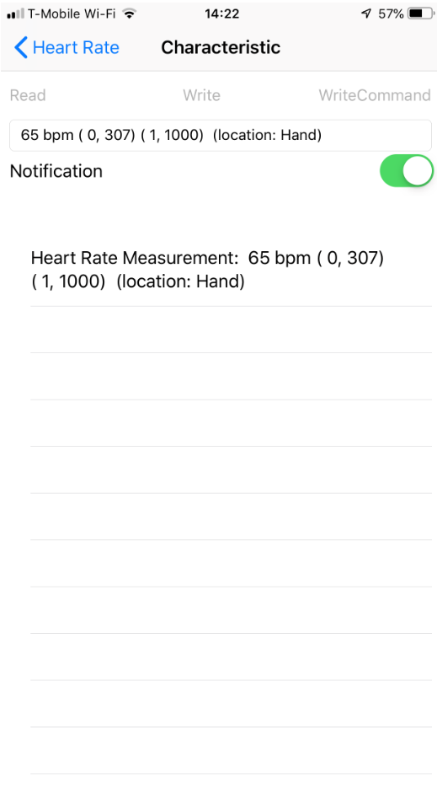

**How to reset STM32.**

If you have uploaded the BLE heart rate project, you need to set the device back to default, in order for you to upload some other project.

* Unplug the jumper from “RX-TX”, as marked in the following picture. Then, plug the jumper into pin 5-pin7.
* Then, unplug the USB cable from the STM32 board to power off the device, and then plug back in again to re-power the device. The device is then reset.
* Then, remove the jumper from pin5-pin7, and put it back to RX-TX,

The board is ready to be programmed with other project now.

